s./



Learning Report – Embedded C – Hardware + Programming + Testing

Course Code: <CODE>

|  |  |  |  |  |  |
| --- | --- | --- | --- | --- | --- |
| **Ver. Rel. No.** | **Release Date** | **Prepared. By** | **Reviewed By** | **Approved By** | **Remarks/Revision Details** |
| 1.0 | 24-12-20 | Sneha K |  | Dr. Vivek K and Bhargav N |  |
| 1.1 | 28-12-20 | Sneha K |  | Dr. Vivek K and Bhargav N |  |
| 1.2 | 29-12-20 | Sneha K |  | Dr. Vivek K and Bhargav N |  |
|  |  |  |  |  |  |
|  |  |  |  |  |  |

**Document History**

Contents

1. Activity 4

**1.1 Linker Script** 4

**1.2 Make file** 5

**1.3 Startup** 6

**1.4 Output Files** 7

**1.5 GitHub Link of code files** 7

2. Activity 7

**2.1 MCU Specific Header File** 8

**2.2 GPIO Driver File** 12

**2.3 Source File** 14

3. Activity 18

**3.1 Screenshot of main logic function** 18

**3.2 Arduino Code** 18

**3.3 GitHub link** 19

References 19

**List of Figures**

Figure 1 Makefile 6

Figure 2 Startup 7

Figure 3 Output files 7

# 1. Activity

## **1.1 Linker Script**

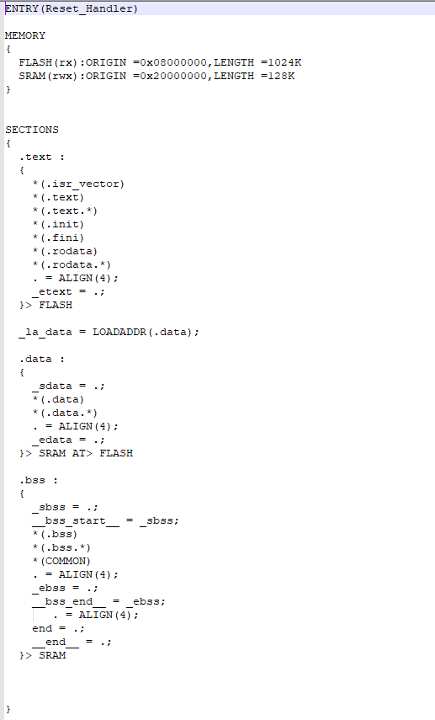

## **1.2 Make file**

**Main code:**

#include <stdio.h>

int main() {

int i, n, t1 = 0, t2 = 1, nextTerm;

printf("Enter the number of terms: ");

scanf("%d", &n);

printf("Fibonacci Series: ");

for (i = 1; i <= n; ++i) {

printf("%d, ", t1);

nextTerm = t1 + t2;

t1 = t2;

t2 = nextTerm;

}

return 0;

}

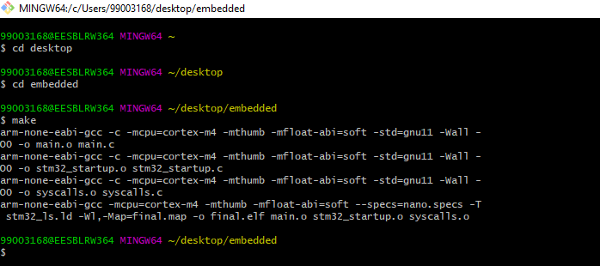

Figure 1 Makefile

## **1.3 Startup**

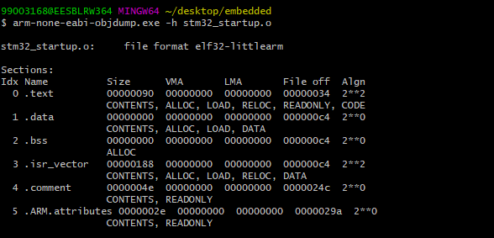

Figure 2 Startup

## **1.4 Output Files**

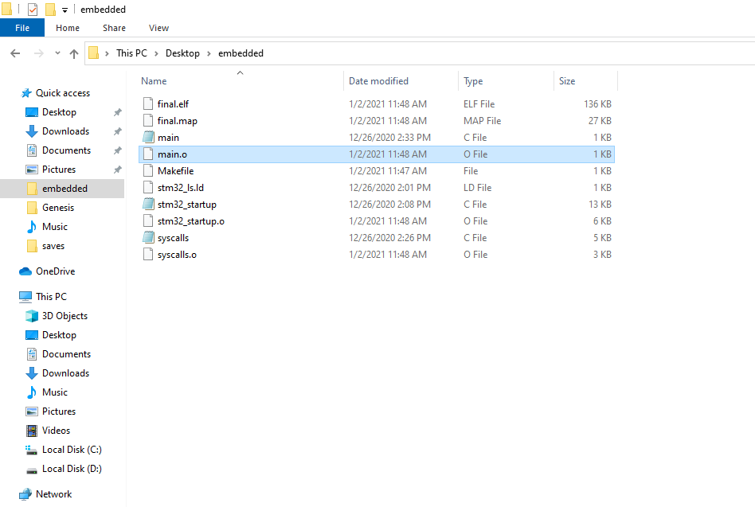

Figure 3 Output files

## **1.5 GitHub Link of code files**

[99003168/Embedded-C (github.com)](https://github.com/99003168/Embedded-C)

# 2. Activity

## **2.1 MCU Specific Header File**

/*

* STM32F4xx.h => MCU specific header file =>driver level

*

* Created on: Dec 28, 2020

* Author: 99003171

*/

**#ifndef** INC_STM32F4XX_H_

**#define** INC_STM32F4XX_H_

**#include**<stdint.h>

**#define** __vo **volatile**

//defining macros for the various memories

**#define** FLASHADDR 0x08000000U

**#define** SRAM1ADDR 0x20000000U

**#define** SRAM2ADDR 0x2001C000U

**#define** SRAMADDR SRAM1ADDR //same as SRAM1

**#define** ROM_BASEADDR 0x1FFF0000U

//defining macros for the various buses

**#define** APB1_BASEADDR 0x40000000U

**#define** APB2_BASEADDR 0x40010000U

**#define** AHB1_BASEADDR 0x40020000U

**#define** AHB2_BASEADDR 0x50000000U

**#define** PERI_BASEADDR APB1_BASEADDR //peripheral base address

//#define AHB3ADDR 0x60000000U

//defining macros for peripherals hanging on to AHB1 bus

**#define** GPIOA_BASEADDR (AHB1_BASEADDR + (0x0000U)) //GPIO Peripherals

**#define** GPIOB_BASEADDR (AHB1_BASEADDR + (0x0400U))

**#define** GPIOC_BASEADDR (AHB1_BASEADDR + (0x0800U))

**#define** GPIOD_BASEADDR (AHB1_BASEADDR + (0x0C00U))

**#define** GPIOE_BASEADDR (AHB1_BASEADDR + (0x1000U))

**#define** GPIOF_BASEADDR (AHB1_BASEADDR + (0x1400U))

**#define** GPIOG_BASEADDR (AHB1_BASEADDR + (0x1800U))

**#define** GPIOH_BASEADDR (AHB1_BASEADDR + (0x1C00U))

**#define** GPIOI_BASEADDR (AHB1_BASEADDR + (0x2000U))

**#define** RCC_BASEADDR (AHB1_BASEADDR + (0x3800U))

//defining macros for peripherals hanging on to AHB2 bus

//NONE

//defining macros for peripherals hanging on to APB1 bus

**#define** SPI2_BASEADDR (APB1_BASEADDR + (0x3800U)) //SPI peripheral

**#define** SPI3_BASEADDR (APB1_BASEADDR + (0x3C00U))

**#define** USART2_BASEADDR (APB1_BASEADDR + (0x4400U)) //USART peripheral

**#define** USART3_BASEADDR (APB1_BASEADDR + (0x4800U))

**#define** UART4_BASEADDR (APB1_BASEADDR + (0x4C00U)) //UART peripheral

**#define** UART5_BASEADDR (APB1_BASEADDR + (0x5000U))

**#define** I2C1_BASEADDR (APB1_BASEADDR + (0x5400U)) //I2C peripheral

**#define** I2C2_BASEADDR (APB1_BASEADDR + (0x5800U))

**#define** I2C3_BASEADDR (APB1_BASEADDR + (0x5C00U))

**#define** TIM2_BASEADDR (APB1_BASEADDR + (0x0000U)) //Timer peripheral

**#define** TIM3_BASEADDR (APB1_BASEADDR + (0x0400U))

**#define** TIM4_BASEADDR (APB1_BASEADDR + (0x0800U))

**#define** TIM5_BASEADDR (APB1_BASEADDR + (0x0C00U))

**#define** TIM6_BASEADDR (APB1_BASEADDR + (0x1000U))

**#define** TIM7_BASEADDR (APB1_BASEADDR + (0x1400U))

**#define** TIM12_BASEADDR (APB1_BASEADDR + (0x1800U))

**#define** TIM13_BASEADDR (APB1_BASEADDR + (0x1C00U))

**#define** TIM14_BASEADDR (APB1_BASEADDR + (0x2000U))

//defining macros for peripherals hanging on to APB2 bus

**#define** SPI1_BASEADDR (APB2_BASEADDR + (0x3000U)) //SPI peripheral

**#define** USART1_BASEADDR (APB2_BASEADDR + (0x1000U)) //USART peripheral

**#define** USART6_BASEADDR (APB2_BASEADDR + (0x0000U))

//#define ADC1-ADC2-ADC3_BASEADDR (APB2_BASEADDR + (0x2000U)) //ADC peripheral

**#define** TIM1_BASEADDR (APB2_BASEADDR + (0x2000U))// Timer peripheral

**#define** TIM8_BASEADDR (APB2_BASEADDR + (0x0400U))

**#define** TIM9_BASEADDR (APB2_BASEADDR + (0x4000U))

**#define** TIM10_BASEADDR (APB2_BASEADDR + (0x4400U))

**#define** TIM11_BASEADDR (APB2_BASEADDR + (0x4800U))

//defining macros for GPIO Peripheral registers

//#define GPIOA_ODR_BASEADDR (AHB1_BASEADDR + (0x0000U) + (0x0014U))

**typedef** **struct**

{ // at port level definitions

__vo uint32_t MODER; // Address offset: 0x00

__vo uint32_t OTYPER; // Address offset: 0x04

__vo uint32_t OSPEEDR; // Address offset: 0x08

__vo uint32_t PUPDR; // Address offset: 0x0C

__vo uint32_t IDR; // Address offset: 0x10

__vo uint32_t ODR; // Address offset: 0x14

__vo uint32_t BSRRL; // Address offset: 0x18

__vo uint32_t BSRRH; // Address offset: 0x1A

__vo uint32_t LCKR; // Address offset: 0x1C

__vo uint32_t AFR [2]; // AFR[0] - AFR Low registers, AFR[1] - AFR high registers // Address offset: 0x20-0x24

} GPIO_Reg_def_t;

//Reg_def_t *pGPIOA = (Reg_def_t*)GPIOA_BASEADDR; //== #define GPIOA ((Reg_def_t*)GPIOA_BASEADDR)

**#define** GPIOA ((GPIO_Reg_def_t*)GPIOA_BASEADDR)

**#define** GPIOB ((GPIO_Reg_def_t*)GPIOB_BASEADDR)

**#define** GPIOC ((GPIO_Reg_def_t*)GPIOC_BASEADDR)

**#define** GPIOD ((GPIO_Reg_def_t*)GPIOD_BASEADDR)

**#define** GPIOE ((GPIO_Reg_def_t*)GPIOE_BASEADDR)

**#define** GPIOF ((GPIO_Reg_def_t*)GPIOF_BASEADDR)

**#define** GPIOG ((GPIO_Reg_def_t*)GPIOG_BASEADDR)

**#define** GPIOH ((GPIO_Reg_def_t*)GPIOH_BASEADDR)

**#define** GPIOI ((GPIO_Reg_def_t*)GPIOI_BASEADDR)

// defining macros for RCC peripheral registers

**typedef** **struct**

{

__vo uint32_t CR;

__vo uint32_t PLLCFGR;

__vo uint32_t CFGR;

__vo uint32_t CIR;

__vo uint32_t AHB1RSTR;

__vo uint32_t AHB2RSTR;

__vo uint32_t AHB3RSTR;

uint32_t RESERVED0;

__vo uint32_t APB1RSTR;

__vo uint32_t APB2RSTR;

uint32_t Reserved1[2];

__vo uint32_t AHB1ENR;

__vo uint32_t AHB2ENR;

__vo uint32_t AHB3ENR;

uint32_t RESERVED2;

__vo uint32_t APB1ENR;

__vo uint32_t APB2ENR;

uint32_t RESERVED3[2];

__vo uint32_t AHB1LPENR;

__vo uint32_t AHB2LPENR;

__vo uint32_t AHB3LPENR;

uint32_t RESERVED4;

__vo uint32_t APB1LPENR;

__vo uint32_t APB2LPENR;

uint32_t RESERVED5[2];

__vo uint32_t BDCR;

__vo uint32_t CSR;

uint32_t RESERVED6[2];

__vo uint32_t SSCGR;

__vo uint32_t PLLI2SCFGR;

__vo uint32_t PLLSAICFGR;

__vo uint32_t DCKCFGR;

} RCC_Reg_def_t;

/*

#define RCC1 ((RCC_Reg_def_t*)0x4002 3800)

#define RCC2 ((RCC_Reg_def_t*)0x4002 3800)

#define RCC3 ((RCC_Reg_def_t*)0x4002 3800)

#define RCC4 ((RCC_Reg_def_t*)0x4002 3800)

#define RCC5 ((RCC_Reg_def_t*)0x4002 3800)

#define RCC6 ((RCC_Reg_def_t*)0x4002 3800)

#define RCC7 ((RCC_Reg_def_t*)0x4002 3800)

#define RCC8 ((RCC_Reg_def_t*)0x4002 3800)

#define RCC9 ((RCC_Reg_def_t*)0x4002 3800)

#define RCC10 ((RCC_Reg_def_t*)0x4002 3800)

#define RCC11 ((RCC_Reg_def_t*)0x4002 3800)

#define RCC12 ((RCC_Reg_def_t*)0x4002 3800)

#define RCC13 ((RCC_Reg_def_t*)0x4002 3800)

#define RCC14 ((RCC_Reg_def_t*)0x4002 3800)

#define RCC15 ((RCC_Reg_def_t*)0x4002 3800)

#define RCC16 ((RCC_Reg_def_t*)0x4002 3800)

#define RCC17 ((RCC_Reg_def_t*)0x4002 3800)

#define RCC18 ((RCC_Reg_def_t*)0x4002 3800)

#define RCC19 ((RCC_Reg_def_t*)0x4002 3800)

#define RCC20 ((RCC_Reg_def_t*)0x4002 3800)

#define RCC21 ((RCC_Reg_def_t*)0x4002 3800)

#define RCC22 ((RCC_Reg_def_t*)0x4002 3800)

#define RCC23 ((RCC_Reg_def_t*)0x4002 3800)

#define RCC24 ((RCC_Reg_def_t*)0x4002 3800)

#define RCC25 ((RCC_Reg_def_t*)0x4002 3800)

*/

**#define** RCC ((RCC_Reg_def_t*)RCC_BASEADDR)

//GPIO clock enable

**#define** GPIOA_pclock_enable() (RCC->AHB1ENR |=(1<<0))

**#define** GPIOB_pclock_enable() (RCC->AHB1ENR |=(1<<1))

**#define** GPIOC_pclock_enable() (RCC->AHB1ENR |=(1<<2))

**#define** GPIOD_pclock_enable() (RCC->AHB1ENR |=(1<<3))

**#define** GPIOE_pclock_enable() (RCC->AHB1ENR |=(1<<4))

**#define** GPIOF_pclock_enable() (RCC->AHB1ENR |=(1<<5))

**#define** GPIOG_pclock_enable() (RCC->AHB1ENR |=(1<<6))

**#define** GPIOH_pclock_enable() (RCC->AHB1ENR |=(1<<7))

**#define** GPIOI_pclock_enable() (RCC->AHB1ENR |=(1<<8))

//GPIO peripheral clock disable macros

**#define** GPIOA_pclock_disable() **do**{ (RCC->AHB1RSTR |= (1 << 0)); (RCC->AHB1RSTR &= ~(1 << 0)); }**while**(0)

**#define** GPIOB_pclock_disable() **do**{ (RCC->AHB1RSTR |= (1 << 0)); (RCC->AHB1RSTR &= ~(1 << 0)); }**while**(0)

**#define** GPIOC_pclock_disable() **do**{ (RCC->AHB1RSTR |= (1 << 0)); (RCC->AHB1RSTR &= ~(1 << 0)); }**while**(0)

**#define** GPIOD_pclock_disable() **do**{ (RCC->AHB1RSTR |= (1 << 0)); (RCC->AHB1RSTR &= ~(1 << 0)); }**while**(0)

**#define** GPIOE_pclock_disable() **do**{ (RCC->AHB1RSTR |= (1 << 0)); (RCC->AHB1RSTR &= ~(1 << 0)); }**while**(0)

**#define** GPIOF_pclock_disable() **do**{ (RCC->AHB1RSTR |= (1 << 0)); (RCC->AHB1RSTR &= ~(1 << 0)); }**while**(0)

**#define** GPIOG_pclock_disable() **do**{ (RCC->AHB1RSTR |= (1 << 0)); (RCC->AHB1RSTR &= ~(1 << 0)); }**while**(0)

**#define** GPIOH_pclock_disable() **do**{ (RCC->AHB1RSTR |= (1 << 0)); (RCC->AHB1RSTR &= ~(1 << 0)); }**while**(0)

**#define** GPIOI_pclock_disable() **do**{ (RCC->AHB1RSTR |= (1 << 0)); (RCC->AHB1RSTR &= ~(1 << 0)); }**while**(0)

//important macro definitions

**#define** ENABLE 1

**#define** DISABLE 0

**#define** GPIO_Pin_Set ENABLE

**#define** GPIO_Pin_Reset DIABLE

**#include** "STM32FXX_GPIO_DRIVER.h"

**#endif** /* INC_STM32F4XX_H_ */

## **2.2 GPIO Driver File**

/*

* STM32Fxx_GPIO_DRIVER.h

*

* Created on: Dec 28, 2020

* Author: 99003171

*/

**#ifndef** INC_STM32FXX_GPIO_DRIVER_H_

**#define** INC_STM32FXX_GPIO_DRIVER_H_

**#include** "STM32F4XX.h"

//GPIO Pin configuration

**typedef** **struct**

{

uint8_t GPIO_PinNumber;

uint8_t GPIO_PinMode;

uint8_t GPIO_PinSpeed;

uint8_t GPIO_PinPuPdControl;

uint8_t GPIO_PinOType;

uint8_t GPIO_PinAltFunMode;

}GPIO_Pin_Config_t;

// GPIO Handle Structure

**typedef** **struct**

{ // pin definitions

GPIO_Reg_def_t *pGPIOx; //this holds base address of GPIO port to which port belongs

GPIO_Pin_Config_t pin_config;//GPIO pin config setting

}GPIO_Handle_t;

// macros for pin numbers

**#define** GPIO_Pin_Number_0 0

**#define** GPIO_Pin_Number_1 1

**#define** GPIO_Pin_Number_2 2

**#define** GPIO_Pin_Number_3 3

**#define** GPIO_Pin_Number_4 4

**#define** GPIO_Pin_Number_5 5

**#define** GPIO_Pin_Number_6 6

**#define** GPIO_Pin_Number_7 7

**#define** GPIO_Pin_Number_8 8

**#define** GPIO_Pin_Number_9 9

**#define** GPIO_Pin_Number_10 10

**#define** GPIO_Pin_Number_11 11

**#define** GPIO_Pin_Number_12 12

**#define** GPIO_Pin_Number_13 13

**#define** GPIO_Pin_Number_14 14

**#define** GPIO_Pin_Number_15 15

// macros for pin modes

**#define** GPIO_PinMode_IN 0 // non interrupt modes

**#define** GPIO_PinMode_OUT 1

**#define** GPIO_PinMode_ALTFN 2

**#define** GPIO_PinMode_ANALOG 3

**#define** GPIO_PinMode_IT_FT 4 // falling edge triggered

**#define** GPIO_PinMode_IT_RT 5 // raising edge triggered

**#define** GPIO_PinMode_IT_RFT 6 // falling & raising edge triggered

// macros for pin speed

**#define** GPIO_Speed_LOW 0 //low speed

**#define** GPIO_Speed_MEDIUM 1 //Medium speed

**#define** GPIO_Speed_FAST 2 //High Speed

**#define** GPIO_Speed_HIGH 3 //Very High speed

// macros for pin PUPD control

**#define** GPIO_PinPuPdControl_PUPD 0 // no pull up pull down

**#define** GPIO_PinPuPdControl_PU 1 // pull up

**#define** GPIO_PinPuPdControl_PD 2 // pull down

**#define** GPIO_PinPuPdControl_Reserved 3 // reserved

// macros for pin OType

**#define** GPIO_PinOType_PP 0 //push pull

**#define** GPIO_PinOType_OD 1 //open drain

// GPIO driver API'S

//Peripheral clock setup

**void** **GPIO_PeriClockControl**(GPIO_Reg_def_t *pGPIOx, uint8_t EnorDi);

//Init and Deinit

**void** **GPIO_Init**(GPIO_Handle_t *pGPIOHandle);

**void** **GPIO_DeInit**(GPIO_Reg_def_t *pGPIOx);

//Data Read and Write

uint8_t **GPIO_ReadFromInputPin**(GPIO_Reg_def_t *pGPIOx, uint8_t PinNumber);

uint16_t **GPIO_ReadFromInputPort**(GPIO_Reg_def_t *pGPIOx);

**void** **GPIO_WriteToOutputPin**(GPIO_Reg_def_t *pGPIOx, uint8_t PinNumber, uint8_t Value);

**void** **GPIO_WriteToOutputPort**(GPIO_Reg_def_t *pGPIOx, uint16_t Value);

**void** **GPIOToggleOutputPin**(GPIO_Reg_def_t *pGPIOx, uint8_t PinNumber);

**#endif** /* INC_STM32FXX_GPIO_DRIVER_H_ */

## **2.3 Source File**

/*

* STM32Fxx_GPIO_DRIVER.c

*

* Created on: Dec 28, 2020

* Author: 99003171

*/

**#include** "STM32FXX_GPIO_DRIVER.h"

// GPIO driver API'S

//Peripheral clock setup

**void** **GPIO_PeriClockControl**(GPIO_Reg_def_t *pGPIOx, uint8_t EnorDi)

{

**if**( EnorDi == ENABLE )

{

**if**(pGPIOx == GPIOA)

{

GPIOA_pclock_enable();

}

**else** **if**(pGPIOx == GPIOB)

{

GPIOB_pclock_enable();

}

**else** **if**(pGPIOx == GPIOC)

{

GPIOC_pclock_enable();

}

**else** **if**(pGPIOx == GPIOD)

{

GPIOD_pclock_enable();

}

**else** **if**(pGPIOx == GPIOE)

{

GPIOE_pclock_enable();

}

**else** **if**(pGPIOx == GPIOF)

{

GPIOF_pclock_enable();

}

**else** **if**(pGPIOx == GPIOG)

{

GPIOG_pclock_enable();

}

**else** **if**(pGPIOx == GPIOH)

{

GPIOH_pclock_enable();

}

**else** **if**(pGPIOx == GPIOI)

{

GPIOI_pclock_enable();

}

}

**else**

{

**if**(pGPIOx == GPIOA)

{

GPIOA_pclock_disable();

}

**else** **if**(pGPIOx == GPIOB)

{

GPIOB_pclock_disable();

}

**else** **if**(pGPIOx == GPIOC)

{

GPIOC_pclock_disable();

}

**else** **if**(pGPIOx == GPIOD)

{

GPIOD_pclock_disable();

}

**else** **if**(pGPIOx == GPIOE)

{

GPIOE_pclock_disable();

}

**else** **if**(pGPIOx == GPIOF)

{

GPIOF_pclock_disable();

}

**else** **if**(pGPIOx == GPIOG)

{

GPIOG_pclock_disable();

}

**else** **if**(pGPIOx == GPIOH)

{

GPIOH_pclock_disable();

}

**else** **if**(pGPIOx == GPIOI)

{

GPIOI_pclock_disable();

}

}

}

//Initialization and Deinitialization

**void** **GPIO_Init**(GPIO_Handle_t *pGPIOHandle)

{

//1. configuring the mode

uint32_t temp=0;

**if**(pGPIOHandle->pin_config.GPIO_PinMode <= GPIO_PinMode_ANALOG )//non interrupt modes

{

temp= pGPIOHandle->pin_config.GPIO_PinMode<<(2*pGPIOHandle->pin_config.GPIO_PinNumber);

pGPIOHandle->pGPIOx->MODER |= temp;

}

//2. configuring the speed

uint32_t temp1=0;

temp1= pGPIOHandle->pin_config.GPIO_PinSpeed<<(2*pGPIOHandle->pin_config.GPIO_PinNumber);

pGPIOHandle->pGPIOx->OSPEEDR |= temp1;

//3. configuring the pu pd control

uint32_t temp2=0;

temp2= pGPIOHandle->pin_config.GPIO_PinPuPdControl<<(2*pGPIOHandle->pin_config.GPIO_PinNumber);

pGPIOHandle->pGPIOx->PUPDR |= temp2;

//4. configuring the output type

uint32_t temp3=0;

temp3= pGPIOHandle->pin_config.GPIO_PinOType<<(pGPIOHandle->pin_config.GPIO_PinNumber);

pGPIOHandle->pGPIOx->OTYPER |= temp3;

//Alternate function

**if**(pGPIOHandle->pin_config.GPIO_PinMode==GPIO_PinMode_ALTFN)

{

uint32_t temp4,temp5;

temp4=pGPIOHandle->pin_config.GPIO_PinNumber/8;

temp5=pGPIOHandle->pin_config.GPIO_PinNumber%8;

pGPIOHandle->pGPIOx->AFR[temp4] |= pGPIOHandle->pin_config.GPIO_PinAltFunMode<<(4*temp5);

}

}

**void** **GPIO_DeInit**(GPIO_Reg_def_t *pGPIOx)

{

**if**(pGPIOx == GPIOA)

{

GPIOA_pclock_disable();

}

**else** **if**(pGPIOx == GPIOB)

{

GPIOB_pclock_disable();

}

**else** **if**(pGPIOx == GPIOC)

{

GPIOC_pclock_disable();

}

**else** **if**(pGPIOx == GPIOD)

{

GPIOD_pclock_disable();

}

**else** **if**(pGPIOx == GPIOE)

{

GPIOE_pclock_disable();

}

**else** **if**(pGPIOx == GPIOF)

{

GPIOF_pclock_disable();

}

**else** **if**(pGPIOx == GPIOG)

{

GPIOG_pclock_disable();

}

**else** **if**(pGPIOx == GPIOH)

{

GPIOH_pclock_disable();

}

**else** **if**(pGPIOx == GPIOI)

{

GPIOI_pclock_disable();

}

}

//Data Read and Write

uint8_t **GPIO_ReadFromInputPin**(GPIO_Reg_def_t *pGPIOx, uint8_t PinNumber)

{

uint8_t value;

value=(uint8_t)((pGPIOx->IDR>>PinNumber)*(0x00000001));

**return** value;

}

uint16_t **GPIO_ReadFromInputPort**(GPIO_Reg_def_t *pGPIOx)

{

uint16_t value1;

value1=(uint16_t)(pGPIOx->IDR);

**return** value1;

}

**void** **GPIO_WriteToOutputPin**(GPIO_Reg_def_t *pGPIOx, uint8_t PinNumber, uint8_t Value)

{

**if**(Value==GPIO_Pin_Set)

{

pGPIOx->ODR |= (1<<PinNumber);

}

**else**

{

pGPIOx->ODR &= ~(1<<PinNumber);

}

}

**void** **GPIO_WriteToOutputPort**(GPIO_Reg_def_t *pGPIOx, uint16_t Value)

{

pGPIOx->ODR = Value;

}

**void** **GPIOToggleOutputPin**(GPIO_Reg_def_t *pGPIOx, uint8_t PinNumber)

{

pGPIOx->ODR = pGPIOx->ODR ^ (1<<PinNumber);

}

# 3. Activity

## **3.1 Screenshot of main logic function**

## **3.2 Arduino Code**

#include<SPI.h>  
volatile boolean received;  
volatile int Slave;  
  
  
void setup()  
{  
  Serial.begin(9600);  
pinMode(MISO, OUTPUT);  
  SPCR |= _BV(SPE);                       //Turn on SPI in Slave Mode  
  received = false;  
  SPI.attachInterrupt();                  //Interuupt ON is set for SPI commnucation  
  }  
ISR (SPI_STC_vect)                        //Inerrrput routine function  
{  
  Slave = SPDR;         // Value received from master  
  received = true;                        //Sets received as True  
}  
void loop()  
{ if(received)                              
  {  
 delay(500);  
 Serial.println(Slave);  
      switch (Slave)  
      {  
        case 0:  
               Serial.println("Human is absent\n");  
               break;  
        case 1:  
               Serial.println("Human is present\n");  
               break;  
        case 2:  
               Serial.println("Sensor value is less than 512\n");  
               break;                
      }  
}  
}

## **3.3 GitHub link**

<https://github.com/99003168/Embedded-C/tree/main/Embedded-C-Project>

# References

[1] <https://youtu.be/B7oKdUvRhQQ>

[2] <https://youtu.be/5aafG5mjZ_Y>

[3] <https://youtu.be/Bsq6P1B8JqI>

[4] <https://youtu.be/2Hm8eEHsgls>